**Q1**) a) Draw the I-V curve for a thermistor in the graph below

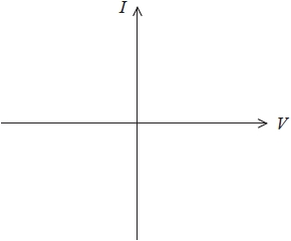

b) How does the resistivity of copper and silicon change with increasing temperature? Why are the behaviours of these two materials different?

…………………………………………………………………………………………………………………………………………………………………………………..

…………………………………………………………………………………………………………………………………………………………………………………..

…………………………………………………………………………………………………………………………………………………………………………………..

…………………………………………………………………………………………………………………………………………………………………………………….

…………………………………………………………………………………………………………………………………………………………………………………….

…………………………………………………………………………………………………………………………………………………………………………………….

**Q2)** a) Nichrome is often used for heating elements in toasters, irons and electric heaters. The radius of nichrome wire is 0.32 mm. Calculate the resistance of a 0.5m wire knowing that resistivity of nichrome is 1.0x10-6. Ω m.

…………………………………………………………………………………………………………………………………………………………………………………….

…………………………………………………………………………………………………………………………………………………………………………………….

…………………………………………………………………………………………………………………………………………………………………………………….

**Q2)** b) encircle the correct answer:

A cylindrical wire has a radius r and length *l*. If both r and *l* are doubled, does the resistance of the wire   
(a) increase (b) decrease (c) remain the same  
*\*Hint: remember resistivity law*

For a forward biased diode as the voltage is increased, does the resistance of the diode  
 (a) increase (b) decrease (c) remain the same

When does a light bulb filament carry more current,   
(a) immediately after it is turned on and the glow of the metal filament is increasing   
(b) after it has been on for a few milliseconds and the glow is steady

Q3) an ideal battery is being charged with a voltage of 12 volts, knowing that it stores 60Ah of current, calculate the work done to charge the battery.

…………………………………………………………………………………………………………………………………………………………………………………..

…………………………………………………………………………………………………………………………………………………………………………………..

…………………………………………………………………………………………………………………………………………………………………………………..

…………………………………………………………………………………………………………………………………………………………………………………….

…………………………………………………………………………………………………………………………………………………………………………………….

…………………………………………………………………………………………………………………………………………………………………………………….